COSC 4606 Project 2

David Asare

Username: Dasare

Tables exported from MS Access to MYSQL workbench

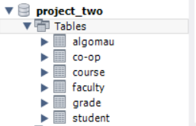

I am using the root user as the database administrator since it has all the administrator privileges.



JDBC Demo

Below is a screenshot of the jdbc driver printing out the first 3 columns from the COURSE database using the InteliJ programming app.

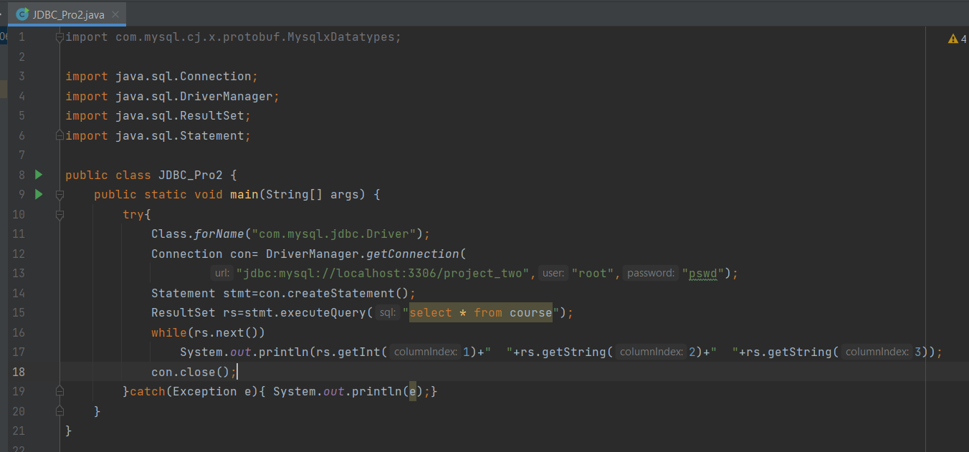

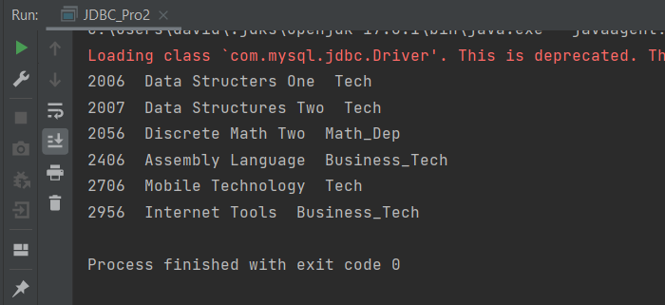

Full COURSE table in MySQL workbench

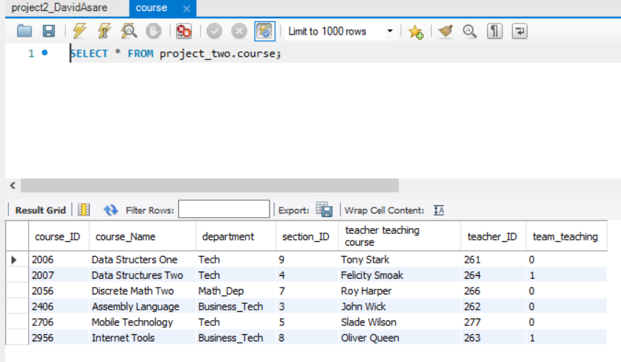

Registrar User

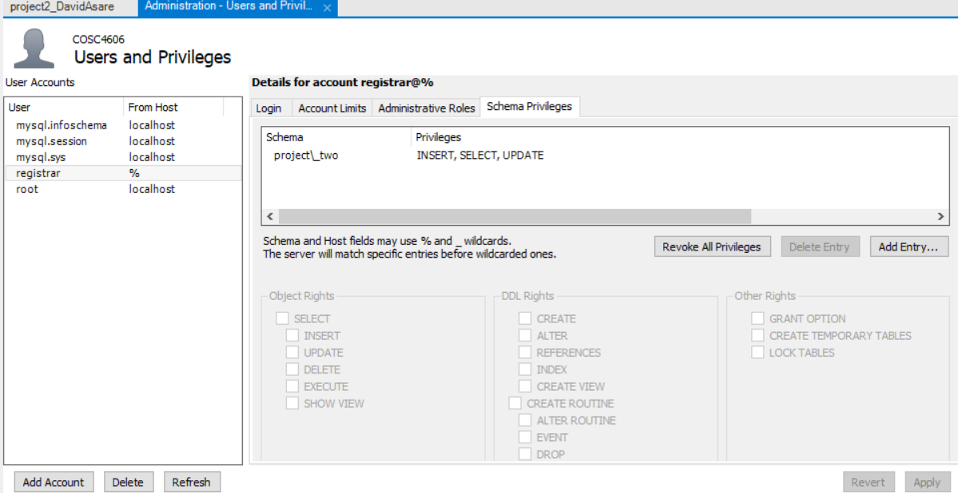

This is the ALGOMAU table below showing a student registered in the university.

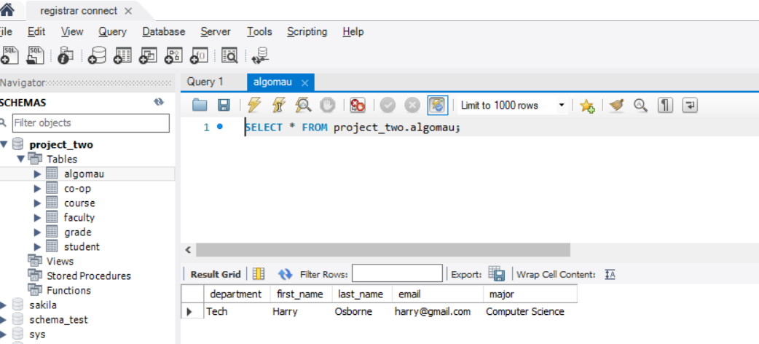

After the insert code was successful in the JDBC, the student “Barbra Gordon” was in enrolled into the Algoma university in the ALGOMAU table.

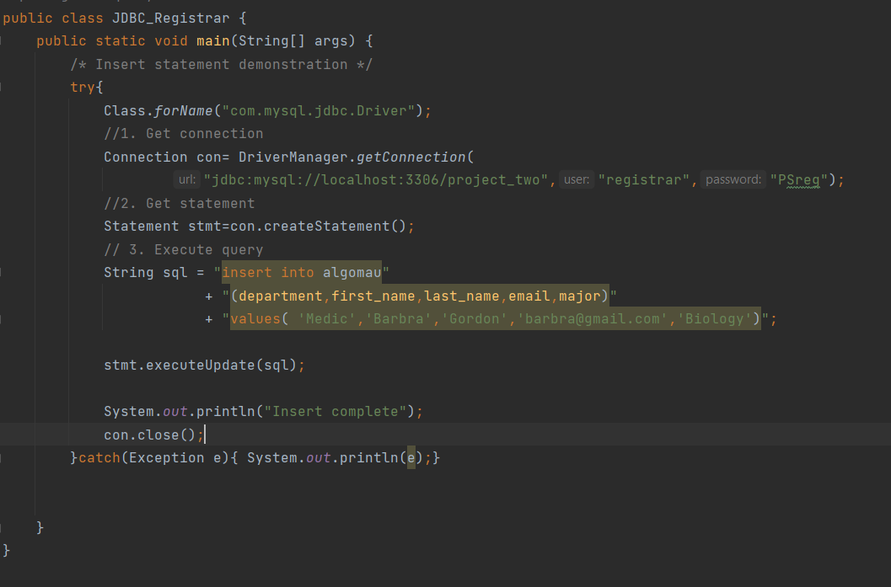

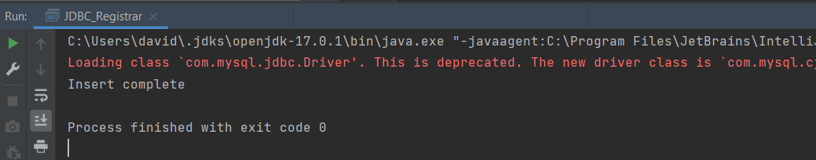

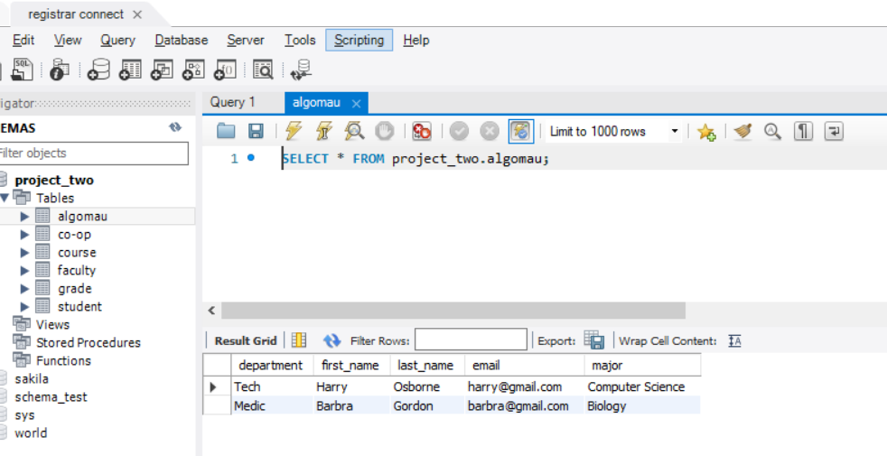

Current grade table.

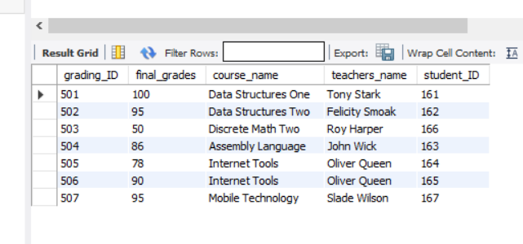

Updating final grade 95 to 96 where “grading_ID” is 502 successfully.

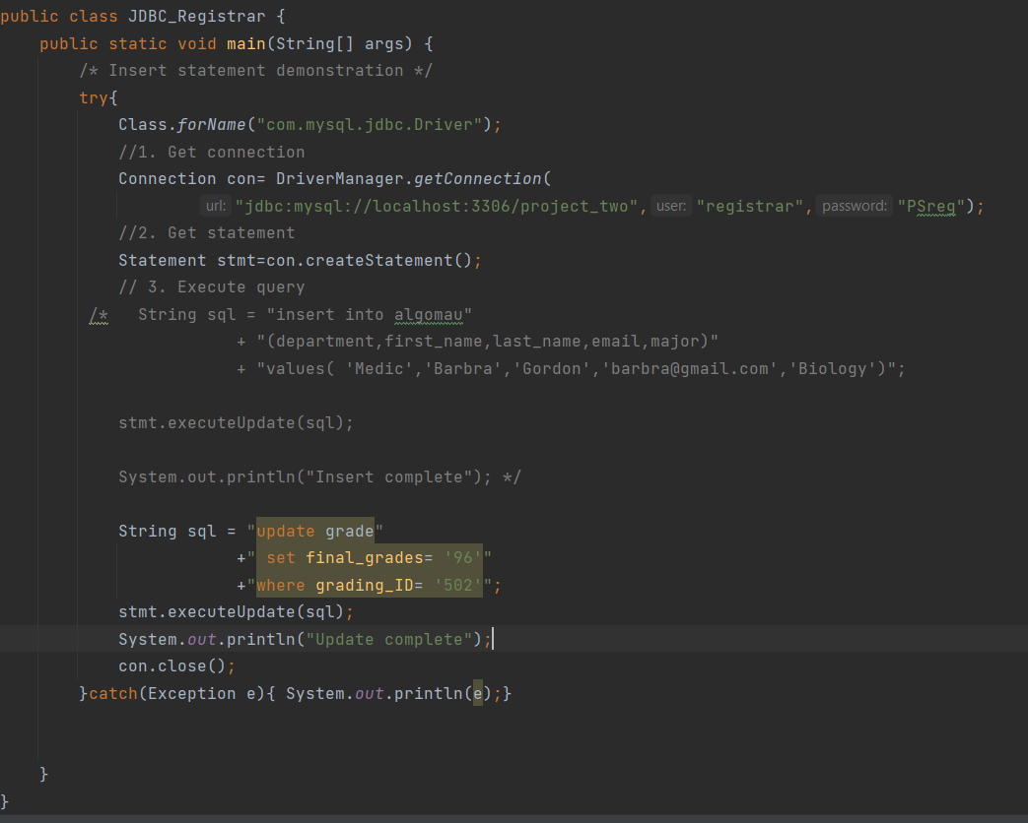

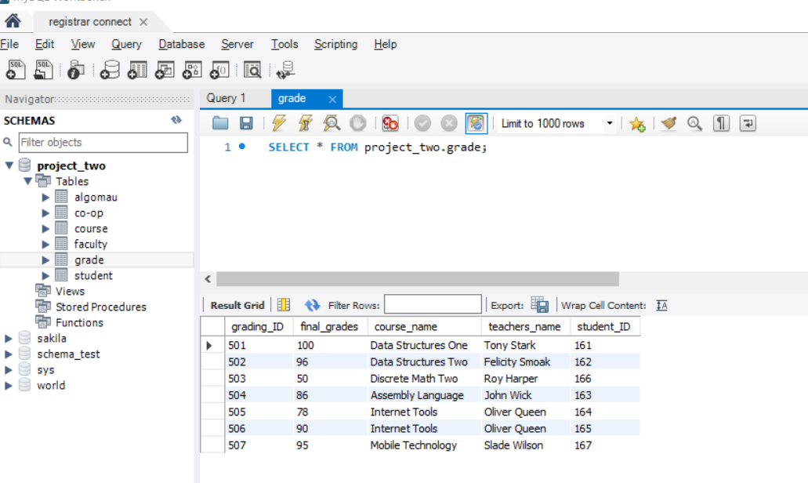

Students User

First I created a view for the student Clark Kent for his academic summary, joining the student and grade tables with dba.

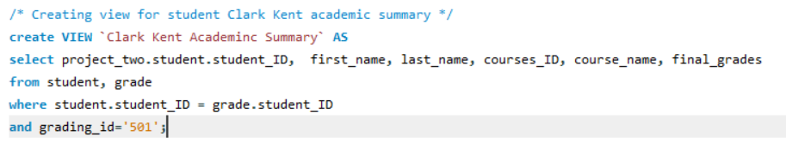

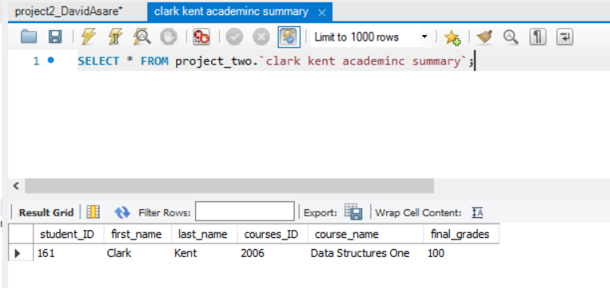

This is the student user with select privilege.

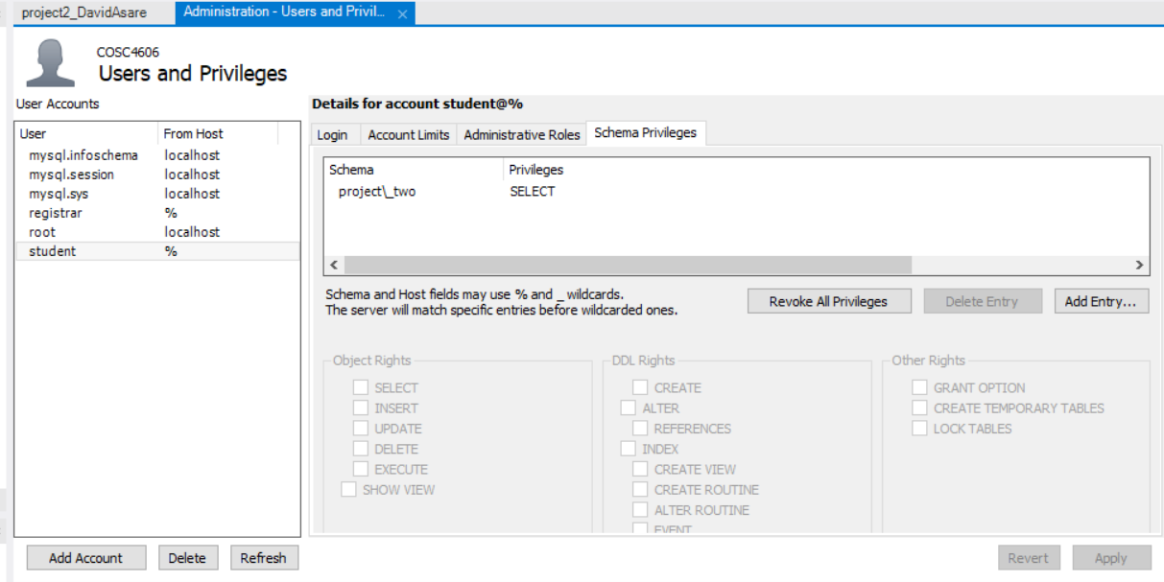

Viewing academic summary for Clark Kent with JDBC successfully.

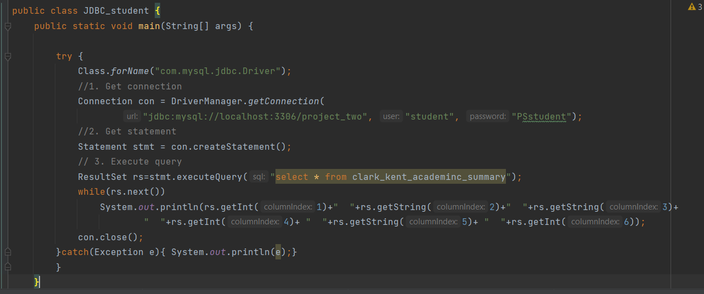

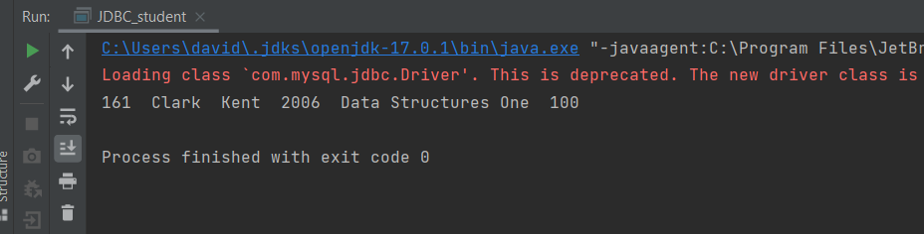

Faculty User

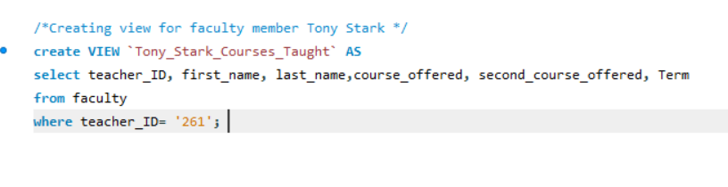

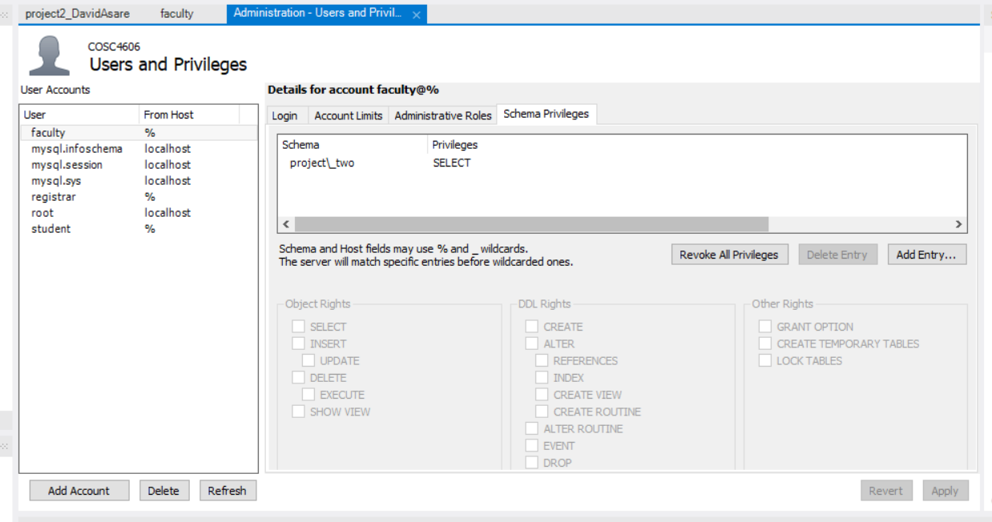

This is going with the scenario of Tony Stark viewing his class list below successfully.

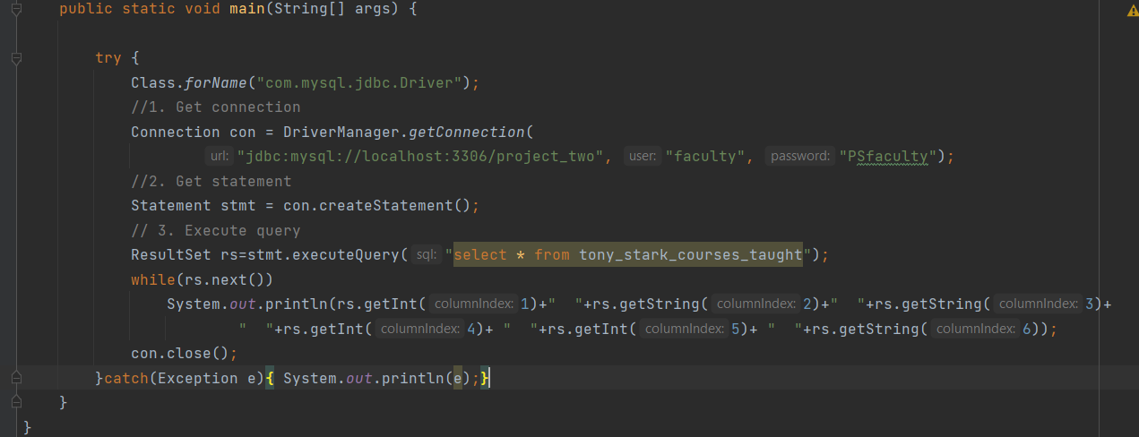

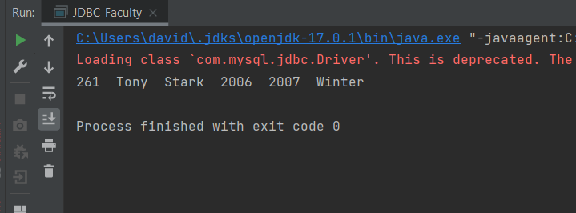

ER-Diagram

Database Schema below.

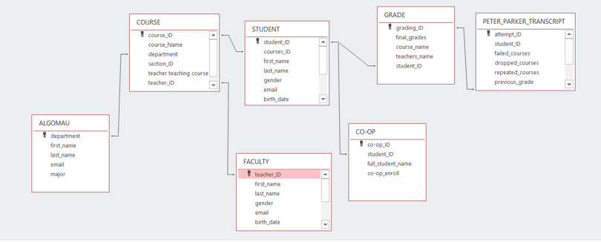

Tables and views of diagram generated in the workbench.

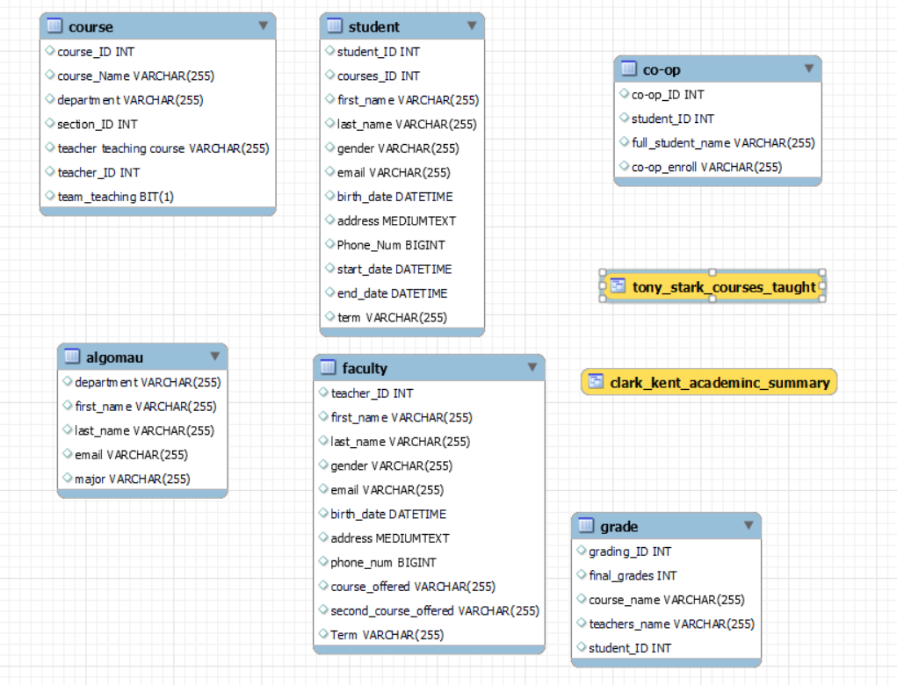

Relationship of the ER-Diagram below.

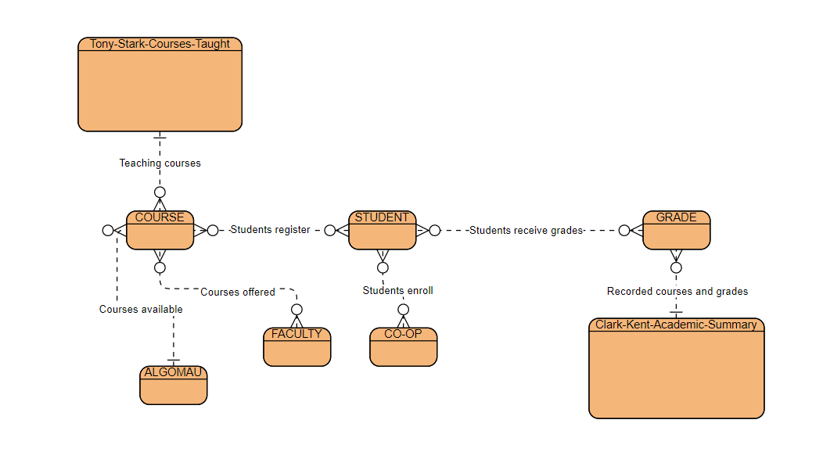

Normal Forms

Co-op table.

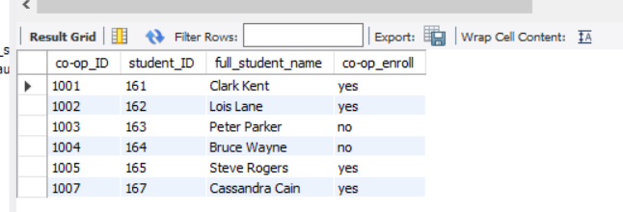

The table is in 1NF because the values are not divided. The columns contain values of the same type and each column has a unique name. This is 2NF as well because the columns depend on the “co-op_ID” attribute.

Algoma Table

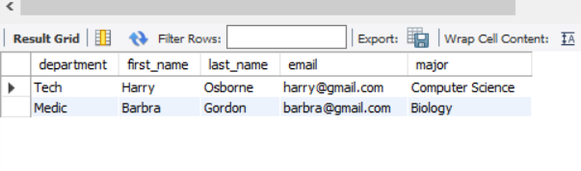

This is 1NF because values are not divided, columns have unique names and values of the same type. It is also 2NF because all the columns can depend on “department” column.

Course Table

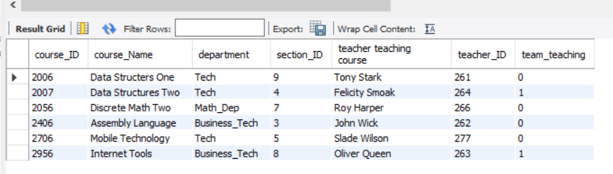

This is 1NF because values are not divided, columns have unique names and values of the same type.

Faculty Table

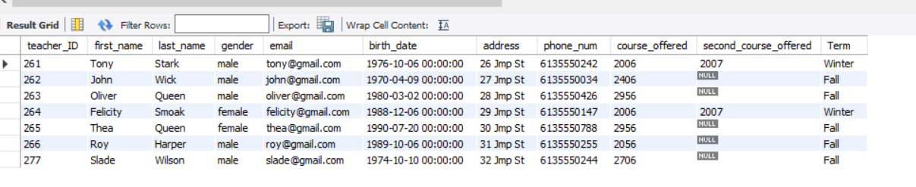

This is 1NF because values are not divided, columns have unique names and values of the same type. It is also 2NF because all the columns can depend on the “teacher_ID” attribute.

Grade

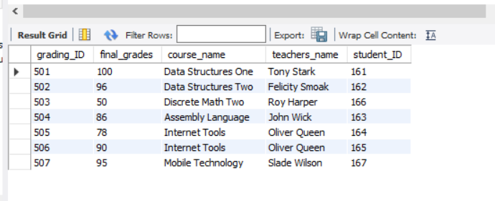

This is 1NF because values are not divided, columns have unique names and values of the same type. It is also 2NF because all the columns can depend on the “grading_ID” attribute.

Student

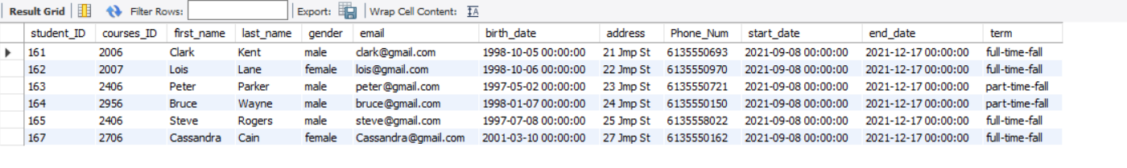

This is 1NF because values are not divided, columns have unique names and values of the same type. It is also 2NF because all the columns can depend on the “student_ID” column.

Forms

Below are the forms viewed in MYSQL workbench which have the same functionality as MS Access in project 1.

Algomau Form

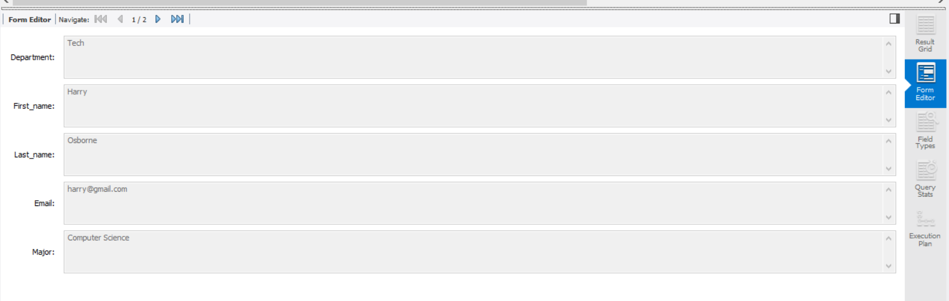

CO-OP Form

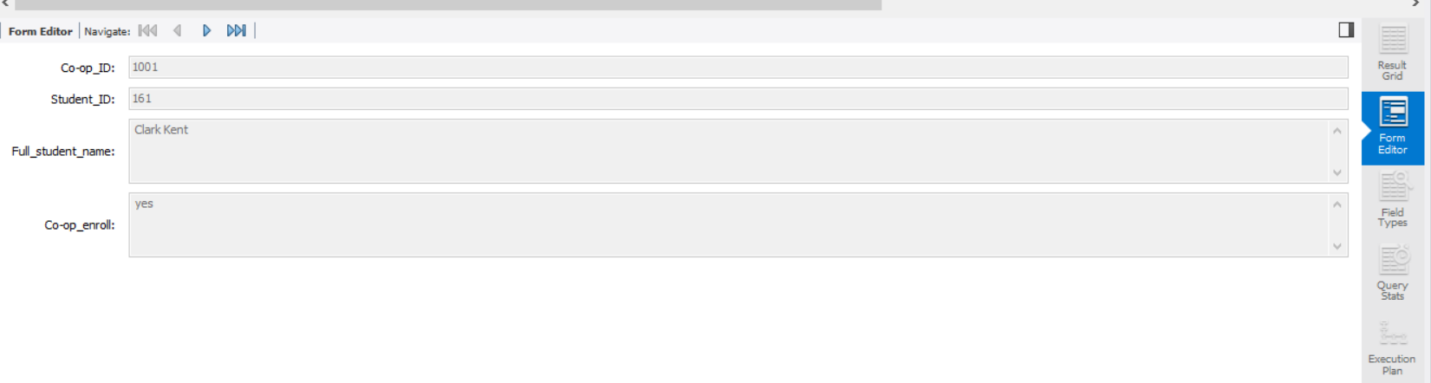

Course Form

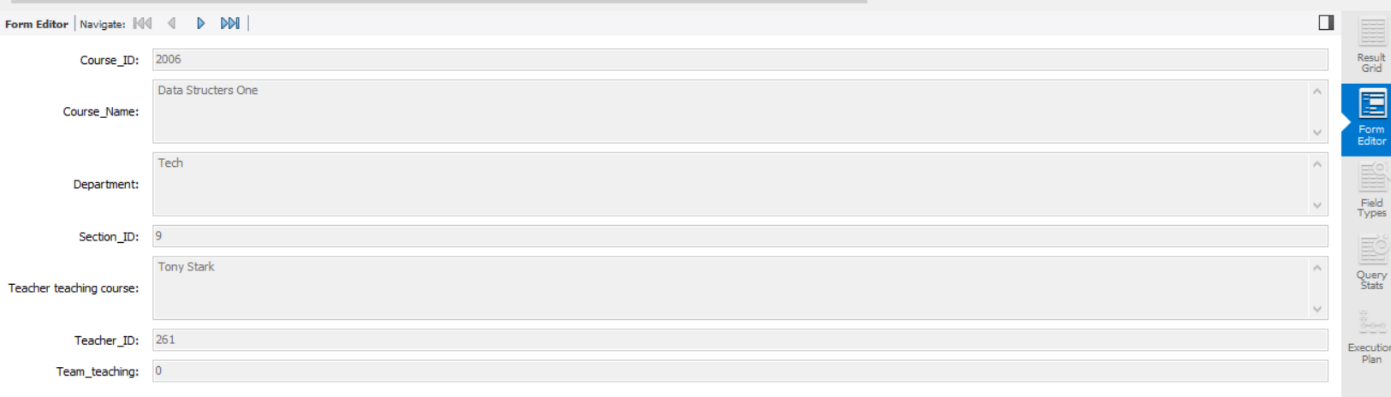

Faculty Form

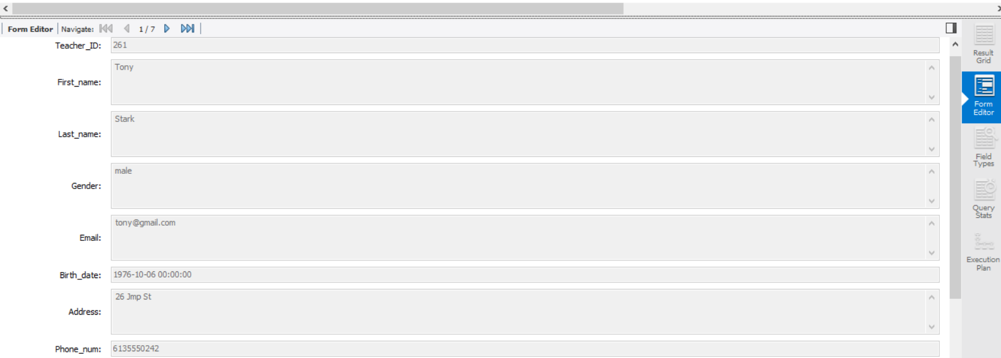

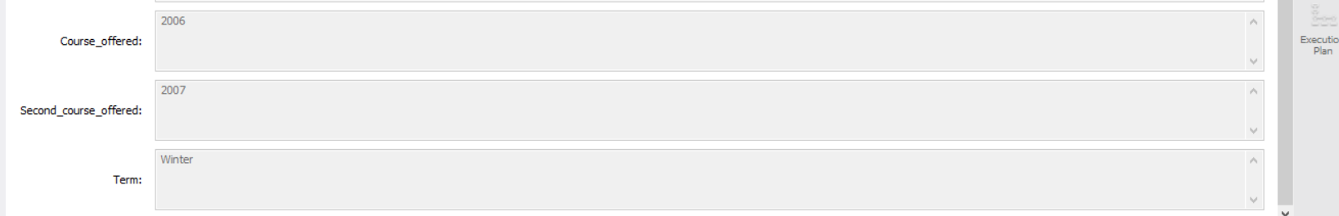

Grade Form

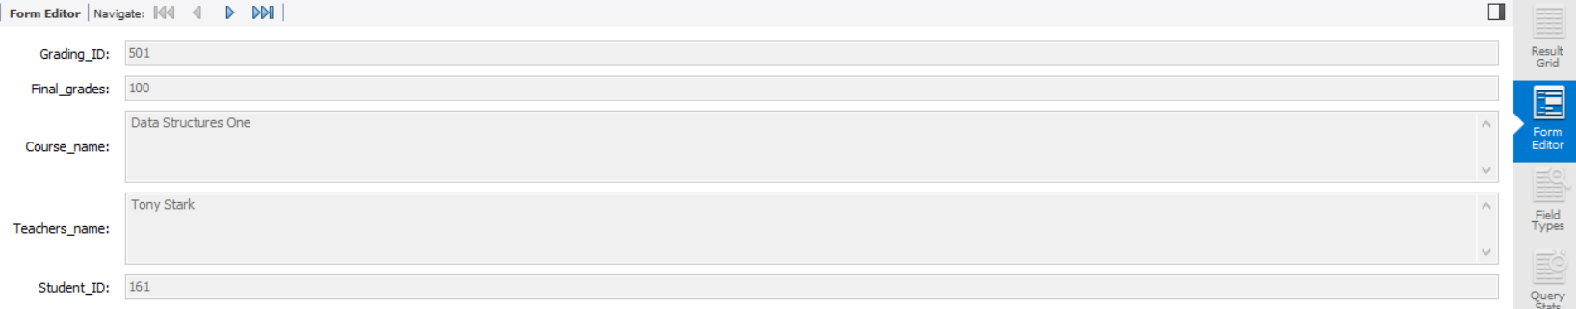

Student Form

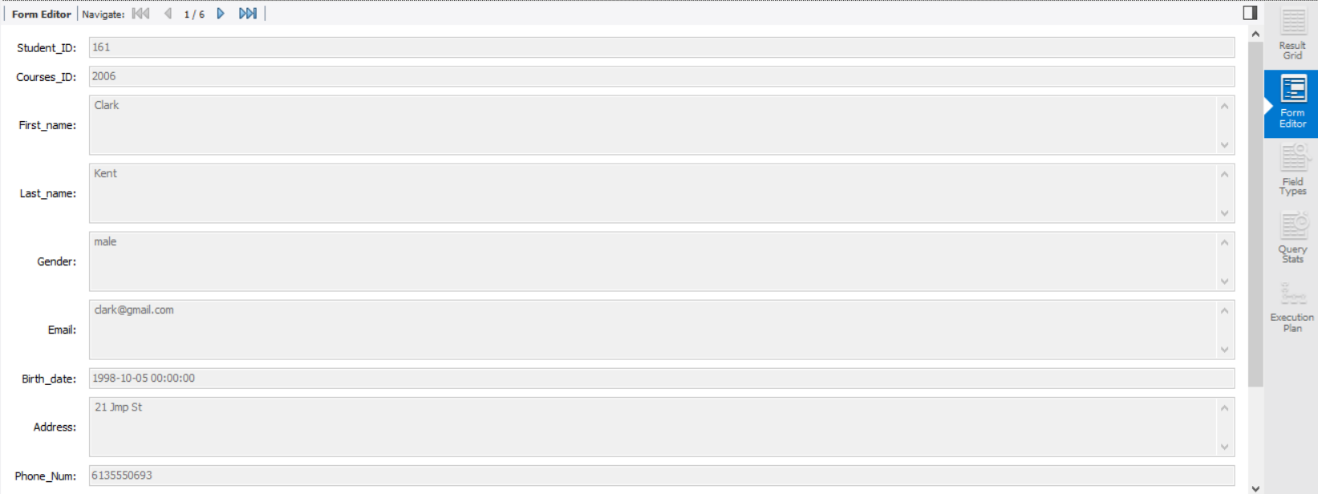

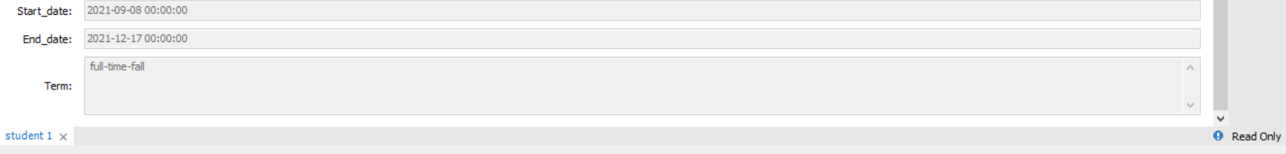

Reports from Project 1

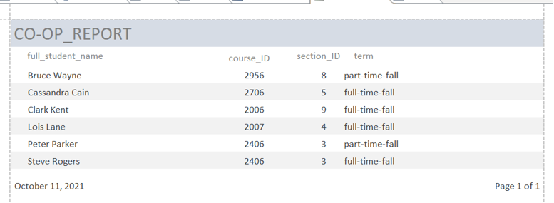

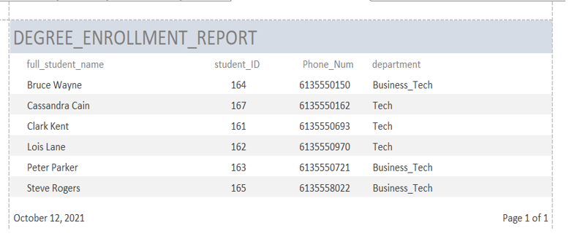

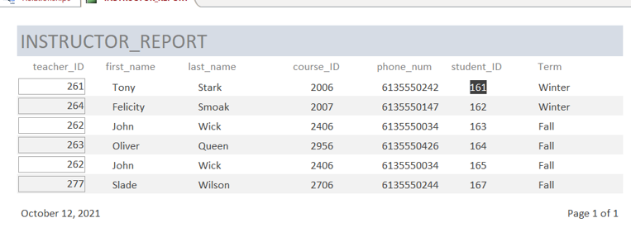

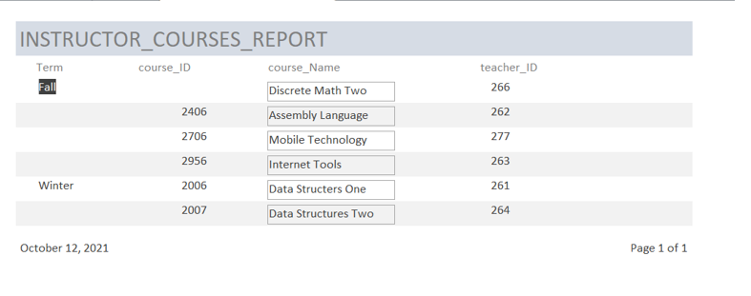

References

<https://www.javatpoint.com/example-to-connect-to-the-mysql-database>

<https://dev.mysql.com/doc/connector-odbc/en/connector-odbc-examples-tools-with-access-export.html>